AB InBev MLOps Challenge v7

At ABI We dream big to create a future with more cheers. That is why we are looking for the best talent out there. We are confident that you are one of those rock stars.

Please start by creating a GitHub private repo with the following name “ABIChallenge_yourname&surname”

Good luck!

# Architecture

Draw a diagram and upload it into the private repo to deploy a ML Model into production on any public cloud, you might consider the following components:

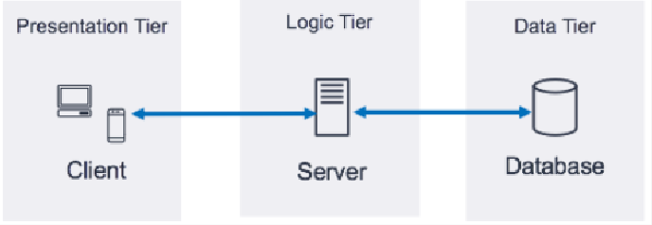

# Collaboration

On the private repo build the following workflow, notice you might use dummy code.*

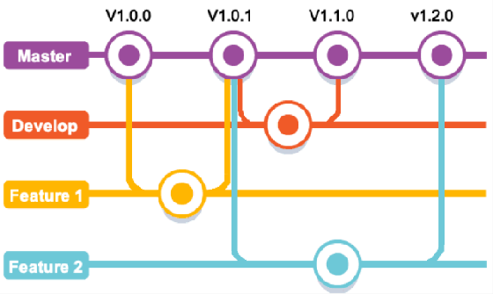

# Automation

Configure Sonar Cloud [https://sonarcloud.io](https://sonarcloud.io/) into the private repo and run some test to validate anything on the next topic.**

# ML Model Deployment

Expose any already trained machine learning model as an API, please keep working on the same private repo.***

Your API might meet the following requirements:

* Should be written in Python following OOP standards.
* Should contain inline documentation.
* You should be running some tests using Sonar Cloud.
* The API might be able to make an estimation one by one or in a batch.
* The code might contain a Docker compose file to run the project locally.
* You might be able to store each estimation in any database.

# Presentation (nice to have)

Point out the key points of your process, main challenges, and findings on a presentation or document. In case you did it, send it by email as well.

Enjoy the challenge and let us know any questions or comments to improve it! See you soon!

Sincerely

ABInBev, MLOps Engineering Team

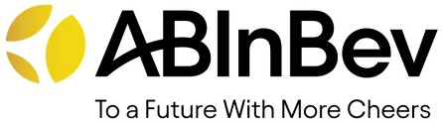

# Notes:

* You might like to use git graphical tools to check this point before.

** Try the free trial for private repos scan.

*** You can use any of the following models or any other you already have (remember NOT to focus on the training but on the deployment of the model as an API that receive an input and respond with the model output)

**** It will be highly valued if you finish this challenge in the next 2 days.

Titanic - <https://www.kaggle.com/startupsci/titanic-data-science-solutions> DS London - <https://www.kaggle.com/kasatkinvl/ds-london-sklearn>

Online Retail - <https://www.kaggle.com/gamzeakman/rfm-for-customer-segmentation> Iris - <https://www.kaggle.com/caesarmario/iris-classification-using-various-ml-models>

Fraud - <https://www.kaggle.com/janiobachmann/credit-fraud-dealing-with-imbalanced-datasets>